ASSIGNMENT 1
1. Creating and Renaming Files/Directories
Objective
Create a directory named test_dir, create an empty file inside it, and rename the file using the mv command.
Commands Used
mkdir test_dir
cd test_dir
touch example.txt
mv example.txt renamed_example.txt
Explanation
- mkdir test_dir — Creates a directory named test_dir.
- cd test_dir — Enters the newly created directory.
- touch example.txt — Creates an empty file named example.txt.
- mv example.txt renamed_example.txt — Renames the file.
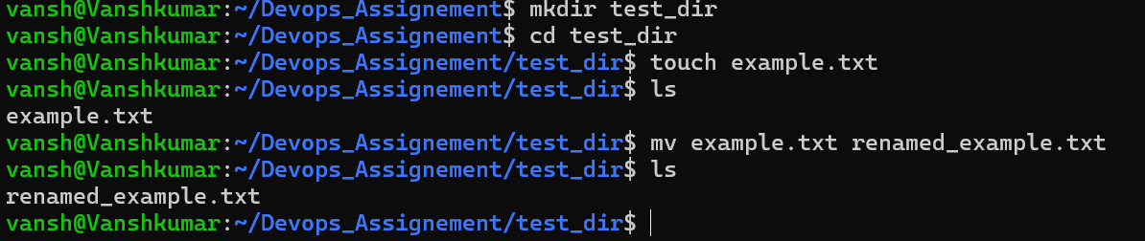
Screenshot

2. Viewing File Contents
Objective
Display the contents of /etc/passwd, and display its first and last five lines.
2.1 Display Complete File
cat /etc/passwd
Explanation
The cat command displays the complete contents of /etc/passwd.
Screenshot
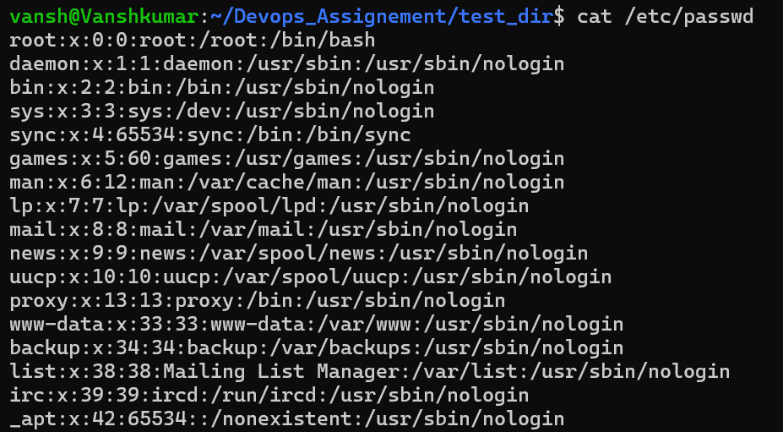
2.2 Display First 5 Lines
head -n 5 /etc/passwd
Explanation
The head command displays the beginning of a file. The -n 5 option limits the output to the first five lines.
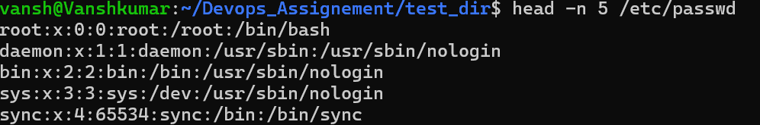
Screenshot

2.3 Display Last 5 Lines
tail -n 5 /etc/passwd
Explanation
The tail command displays the end of a file. The -n 5 option limits the output to the last five lines.
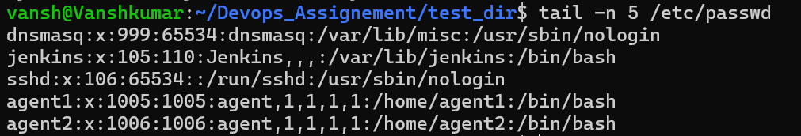
Screenshot

3. Searching for Patterns
Objective
Find all lines in /etc/passwd containing the word root.
Command
grep "root" /etc/passwd
Explanation
grep searches text for a specified pattern. In this command, it searches /etc/passwd for lines containing root.
Screenshot

4. Zipping and Unzipping
Objective
Compress test_dir into test_dir.zip and extract it into unzipped_dir.
4.1 Create ZIP File
Run this from the directory containing test_dir:
zip -r test_dir.zip test_dir
Explanation
- zip — Creates a ZIP archive.
- -r — Recursively includes the directory and its contents.
- test_dir.zip — Name of the ZIP file.
- test_dir — Directory being compressed.
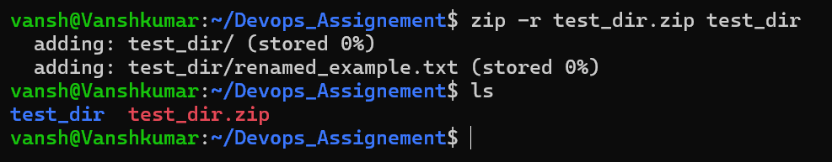
Screenshot

4.2 Create Destination Directory & Extract ZIP File
mkdir unzipped_dir
unzip test_dir.zip -d unzipped_dir
Explanation
The unzip command extracts the contents of test_dir.zip. The -d option specifies the destination directory.
Verification
ls -R unzipped_dir
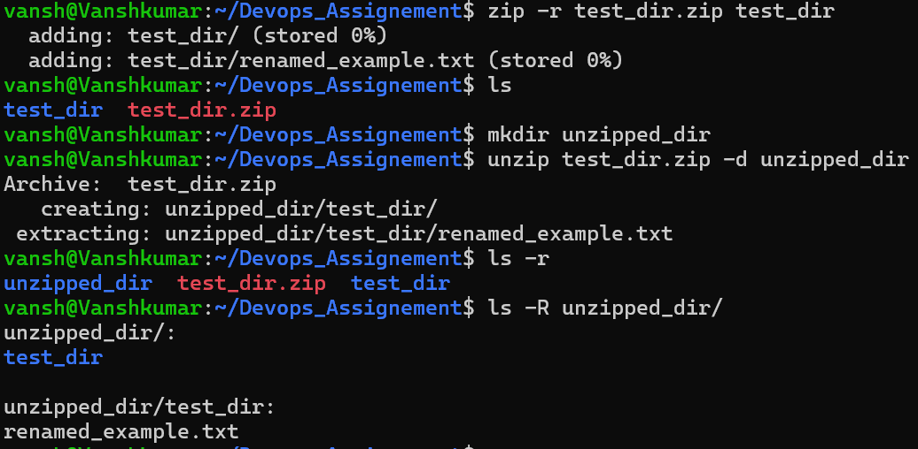
Screenshot

5. Downloading Files
Objective
Download a file from a URL using wget.
Command
wget https://example.com/sample.txt
Explanation
wget is a command-line utility used to download files from the Internet.
Verification
ls -l sample.txt
Screenshot
Insert screenshot here
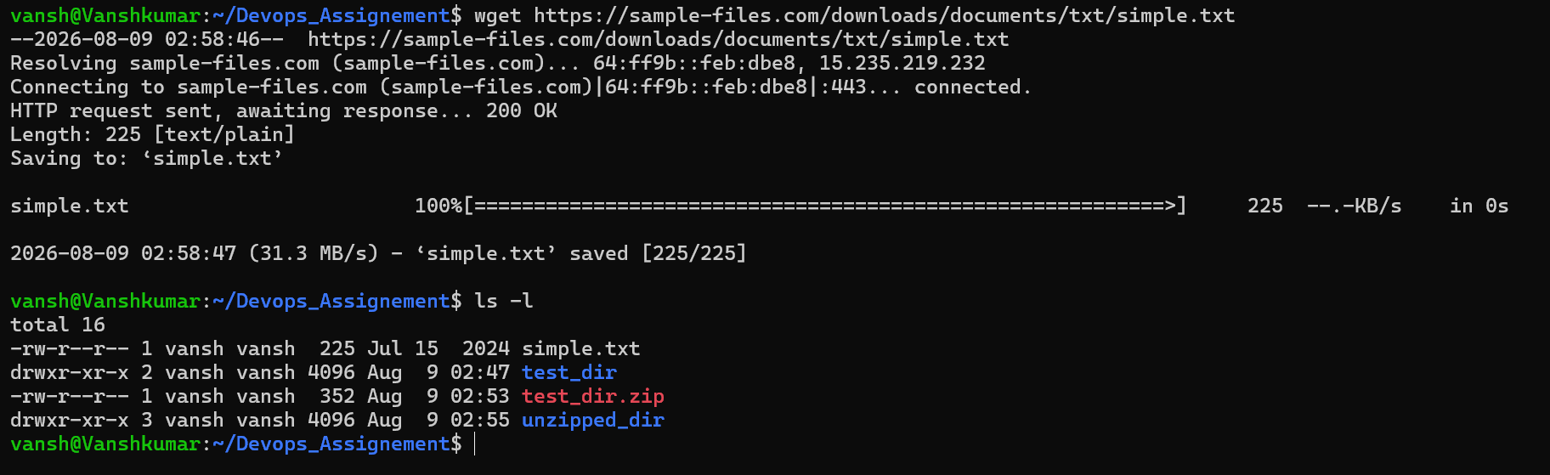
6. Changing File Permissions
Objective
Create secure.txt and make it read-only for everyone.
Commands
touch secure.txt
chmod 444 secure.txt
Verification
ls -l secure.txt
Expected permission format:
-r--r--r--
Explanation
chmod changes file permissions.
The permission value 444 means:
User | Permission
Owner | Read
Group | Read
Others | Read
Therefore, nobody has write or execute permission.
Screenshot
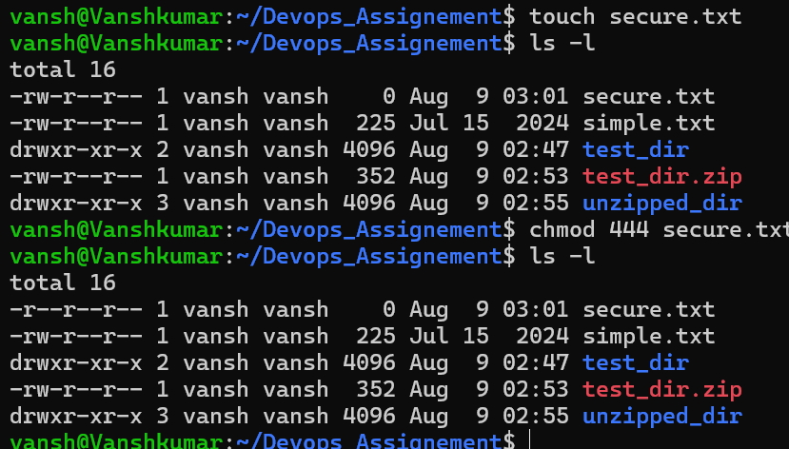
7. Working with Environment Variables
Objective
Create an environment variable named MY_VAR with the value Hello, Linux!.
Command
export MY_VAR="Hello, Linux!"
Verification
echo $MY_VAR
Expected output:
Hello, Linux!
Explanation
export creates an environment variable that is available to the current shell and processes launched from it.
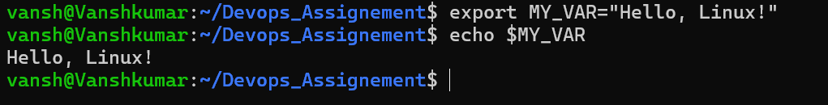
Screenshot

